**Ideation Phase**

**Empathize & Discover**

|  |  |
| --- | --- |
| Date | 26.06.2025 |
| Team ID | SWUID20240036329 |
| Project Name | Ora Social Media App |
| Maximum Marks | 4 Marks |

**Empathy Map Canvas:**

Understand the **needs, frustrations, and behaviors** of users who want a clean, friendly, and meaningful social media experience.

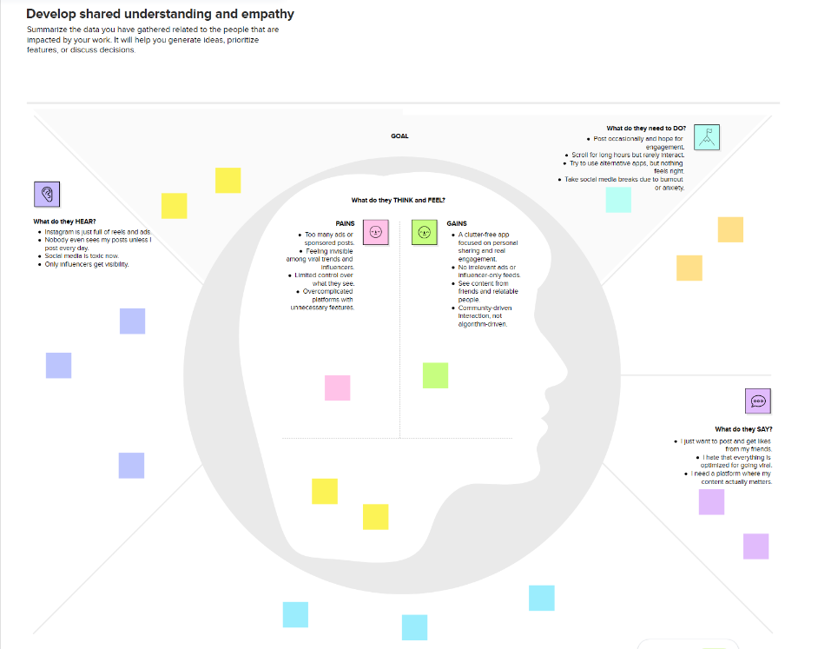

Reference: <https://www.mural.co/templates/empathy-map-canvas>